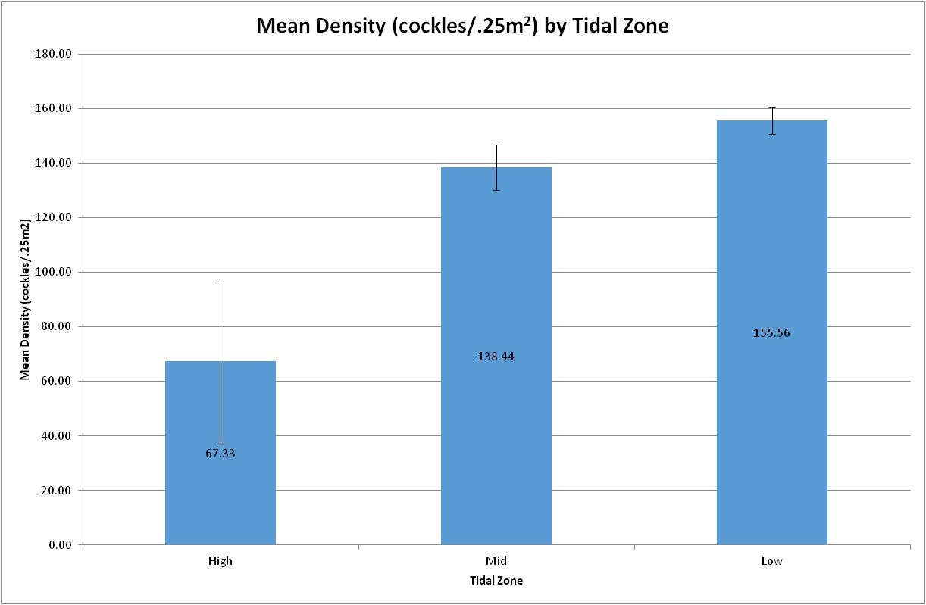

**Mean cockle density (cockles/.25m2) for the High, Mid and Low tidal zones. Error bars are +/- 1 standard error. The effect of tidal zone is significant (*F*2,21 = 7.115; *p*=.004). Mid and Low means are not significantly different by Tukey's HSD.**